Cycling The DMZ
VACDMZ
4 Days / 3 Nights

Day | Destination | Activity | Difficulty | Transfer | Meals | Hotel
1 | Hue – Dong Ha | Cycling up to 70 km | Medium | 30 mins | -/L/D | Muong Thanh Quang Tri
2 | Dong Ha – Khe Sanh | Cycling up to 60 km | Medium | N/A | B/L/D | Khanh Phuong
3 | Khe Sanh – A Luoi | Cycling up to 60-90 km | Medium | N/A | B/L/D | A Luoi Retreat
4 | A Luoi – Hue | Cycling up to 70 km | Medium | N/A | B/L/- | -

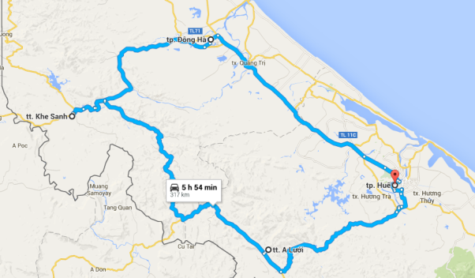

Day 1: Hue – Dong Ha (-/L/D)

Begin the tour by meeting up with the guide (at the hotel), followed by a short transfer out of town. The cycle begins heading along the peninsula between Pha Tam Giang lagoon and the coast. The ride is quite stunning, running along quiet roads with views of sand dunes, colorful cemeteries, rice fields, temples, and farmers tending to their water buffalo. The route is smooth and mostly flat; expect warm greetings and hellos around every corner!

Overnight in Dong Ha

Distance and journey time:
Transfer from hotel to out of town: 30 mins
Cycling distance up to: 70 km
Difficulty: Medium

Day 2: Dong Ha – Khe Sanh (B/L/D)

From Dong Ha, head back to the beach and up the coast toward Vinh Moc, visiting the villages of Cua Tung and Cua Viet. The village of Vinh Moc found itself tragically positioned in one of the most heavily bombed areas of Vietnam. In order to escape this bombardment, the villagers constructed approximately 2.8 km of underground tunnels which they used as a refuge to survive the bombings. Three hundred people lived intermittently in the tunnels from 1966 to 1971.

Continue southwest to begin climbing up to the town of Khe Sanh, where one the most important battles of the Vietnam War took place; the former base has bunkers, helicopters and a museum on display. Pass by ‘Rockpile’ along the way, a high, isolated mountain that was an important lookout point by the Americans and Dakrong Bridge, where access points once ran into the Ho Chi Minh Trail.

Overnight in Khe Sanh

Distance and journey time:
Cycling distance up to: 60 km
Difficulty: Medium

Day 3: Khe Sanh – A Luoi (B/L/D)

Begin the morning with a visit to the Khe Sanh combat base where relics of the war are exhibited and see the airstrip. Then ride through spectacular scenery, mainly downhill, from the Laos border to the Dakrong River. Cross the river by bridge and ride along the waterway to what was considered the southern part of the Ho Chi Minh Trail. The ride today is a fabulous mix of rolling terrain and wild scenery.

Overnight in A Luoi

Distance and journey time:
Cycling distance up to: 60-90 km
Difficulty: Medium

Day 4: A Luoi – Hue (B/L/-)

Due to the bad roads just south of A Luoi, today will venture off the Ho Chi Minh Trail and head across the country to Hue. The 60km ride through the middle of Vietnam is on back roads before hitting Highway 1 just a few kilometres south of Hue. There is the option of transferring by road or continuing by bike to the center of Hue at this part.

Once back in Hue, the guide and driver will provide a drop off at the chosen hotel in Hue.

Distance and journey time:
Cycling distance up to: 70 km
Difficulty: Medium

*****End of services by EXO Adventure*****
An itinerary may at times be altered by our guides due to local conditions, the skill of participants and other unexpected circumstances. Our priority is always the experience and safety of our clients.

Rates & Conditions

Accommodation
City | Hotel | Hotel Category | Room Type
Dong Ha | Muong Thanh Quang Tri | 3 star + | Deluxe
Khe Sanh | Khanh Phuong | 3 star | Standard
A Luoi | A Luoi Retreat | 3 star | ROH

Pricing: in USD per person for shared twin/double
Rates are valid until 31 December 2027

Number of Persons | 1 | 2 | 3-4 | 5-6 | 7-10 | 11-15 | SGL Supp
Net price per person | 1489 | 847 | 659 | 574 | 582 | 499 | 77
Note:
- Reservations during peak times (Christmas, New Year, Vietnamese Lunar New Year, National Holidays) may be subject to supplementary charges and compulsory meals
- Supplement for E-bike: 189 USD

Our services include:
- 1 EXO Adventure Certified English-speaking Guide
- Additional local guide for 10-15 pax
- 1 first aid kit per guide
- Each guide will have a full set of travel bike tools
- Bike and Helmet
- 1 refillable personal biking bottle per person
- Plenty of water provided throughout the day when cycling
- Snacks and fresh fruits
- Vehicle support while cycling
- Private air-conditioned vehicle for transfer and back up as itinerary
- Meals as mentioned in the itinerary (B – Breakfast, L – Lunch, D – Dinner)
- Admission fees where applicable in the itinerary
- Accommodation as listed above
- Flight re-confirmations

Our services don’t include:
- Visa arrangement
- International and domestic flights
- Meals other than mentioned above
- Soft drinks, or beverages beyond water – we can add this into costs at agents request
- Beverage and alcoholic drinks at mealtimes
- Tips for Guides and local crews
- Energy drinks or powders, performance bars, or performance gels (Gatorade, Power bars, Gue, Isostar, etc)
- Personal Travel Insurance
- Personal expenditure (Laundry, telephone)
- Any other services not clearly mentioned in the itinerary and in the inclusive portion.
- Other language speaking guides
- Credit card/bank transfer fees

Important notes:
- We strongly recommend the purchase of travel insurance (covering emergency medical evacuation) for trips.
- Prices are valid 30 days from date of offer. Past this date price and conditions may be readjusted.
- The cost of air tickets is subject to change without prior notice by the airlines.
- Reservations during peak times (Christmas, New Year, Vietnamese Lunar New Year, National Holidays) may be subject to supplementary charges.
- Rooms at hotels are available only from 14:00 on arrival day till 12:00 on departure date. A supplement will be added if early check-in or late check-out is desired.
- Please note that all the above services & tours have yet to be booked, they are proposed for your information only and we will not make any reservations before we receive your confirmation to do so.
- If one or some proposed service(s) is (are) not available at the moment of booking, we will try to find other possibilities/options or other similar service(s) in order to avoid changes to the program.

