Honeymoon Japan
JLTHMJ– 9 Days / 8 Nights and Extension
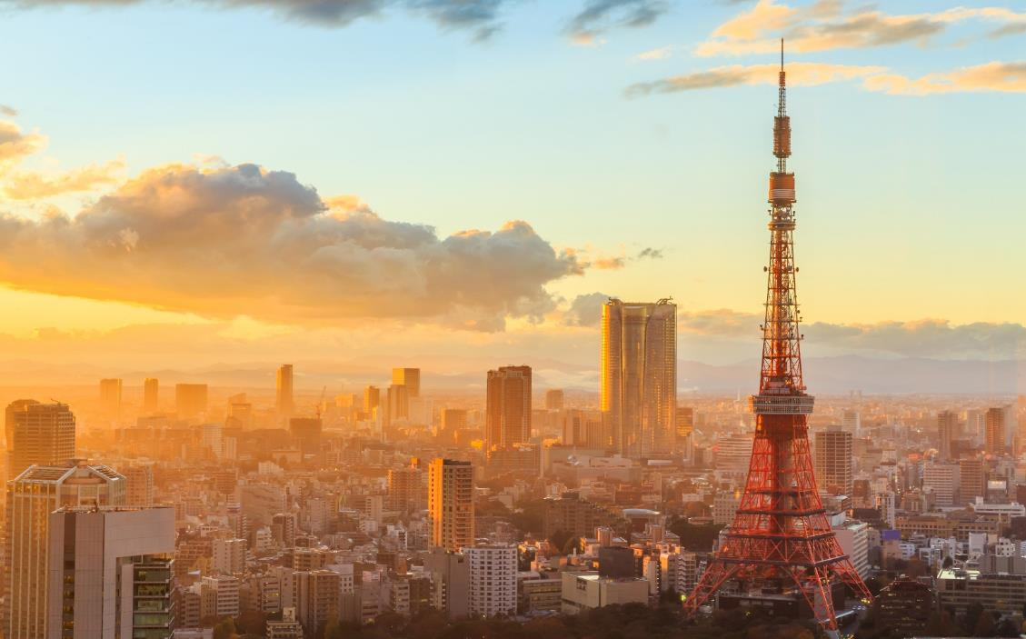
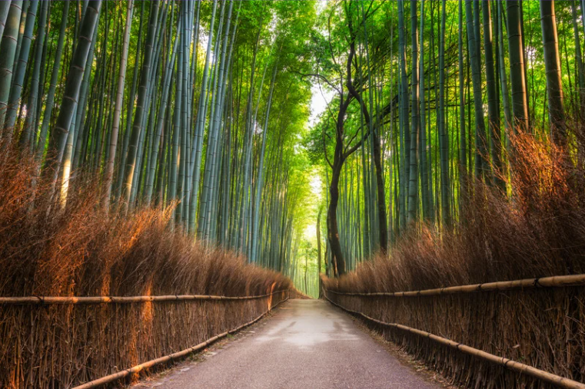 | 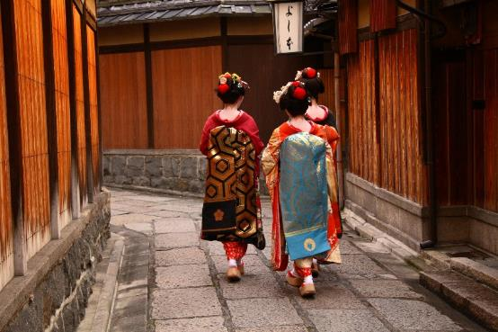

Travel Itinerary

Unique selling points and introduction

Highlights:
- Enjoy private guided excursions
- Partake in a wedding Kimono photoshoot
- Dine in the company of a geisha
- Stay in a ryokan with private onsen
Overview:
Be swept away by the culture and elegance of Japan on this exclusive honeymoon holiday. Enjoy a mix of private guided tours, incredible cultural encounters and indulgent meals while traveling from Tokyo to Kanazawa and Kyoto. As an option, choose to relax with a romantic beach stay on Miyako Island or indulge in the fantastic food and beautiful landscapes of Hokkaido.

Day 1: Arrival in Tokyo | -/-/-

Upon arrival to Tokyo’s airport, our representative will be waiting to assist with transport to Tokyo Hotel via private vehicle.

After the check-in, the rest of the day is at leisure.

Distance and journey time (approximation):
Narita International Airport (NRT) to Central Tokyo: 1.5 h
Haneda International Airport (HND) to Central Tokyo: 50 min

Overnight in Tokyo at the Fairmont 6 Stars (Super Deluxe)

Day 2: Tokyo | B/-/-

Enjoy a day touring Tokyo city alongside an expert local guide and private transport.

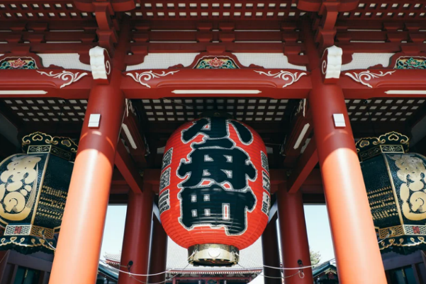
One of the main visits of the day will be to Asakusa, part of Tokyo’s shitamachi (old town). This charming district exudes a nostalgic charm and showcases Tokyo's traditional side. At the heart of Asakusa stands the iconic Senso-ji, Japan's oldest Buddhist temple, drawing hordes of locals and tourists alike seeking blessings and cultural insight. The vibrant Nakamise Street leading to the temple offers a bustling market with a myriad of stalls selling traditional snacks, souvenirs, and handicrafts.

While still in Asakusa, take the time to create a unique souvenir by experiencing Edo Kiriko glass cutting. This traditional way of cutting glass creates elaborate patterns on the shining surfaces of cups and bottles.
Choose the shape of the glass and do some practice cutting with instruction from the artisans before painting the chosen design using the stamp provided by the shop. Next, it’s cutting time, where the decorations on the glass become real.
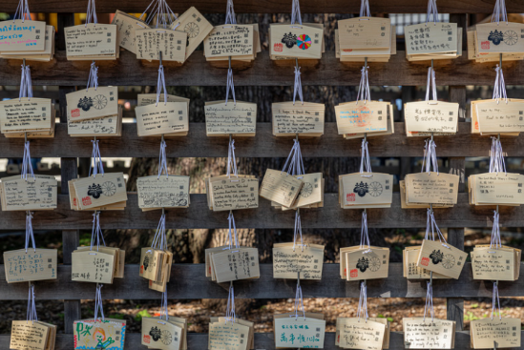
In the afternoon, stop by Meiji Jinju, Tokyo’s most famous Shrine, including a chance to experience a traditional Shinto purification dance and receive a blessing from a Shinto Priest.

Finish the day by driving past famous Tokyo landmarks including Ginza, the Imperial Palace, and the Shibuya ‘scramble’ crossing.

Time:
Duration (guided tour): 8 h
*including pick-up, drop-off, and transit times

Overnight in Tokyo at the Fairmont 6 Stars (Super Deluxe)

Day 3: Tokyo, Wedding Kimono Experience & Photoshoot | B/-/-

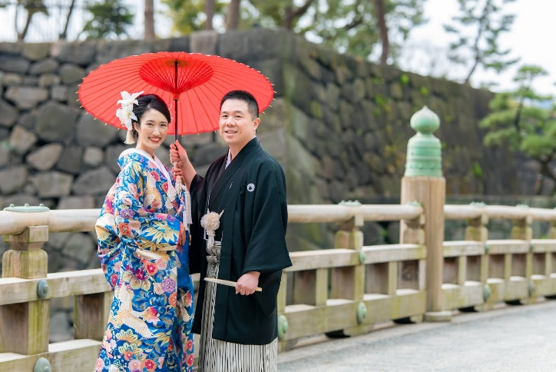
Celebrate the special occasion by discovering the world of Japanese wedding kimonos. Assisted by a kimono expert, dress in the exquisite traditional garment and enjoy an outdoor photoshoot.

This half day experience will begin with a visit to the studio of a professional kimono dresser where guests are treated to a traditional fashion experience.

Slip into a kimono, the iconic traditional Japanese costume. Today’s kimonos are specifically chosen from a collection of wedding garments to celebrate the special occasion.

The dressing itself is a complicated process of layers that will give guests a greater appreciation for the complexity of wearing a kimono.

Once appropriately dressed, the happy couple will join a professional photographer for an on-site shoot at an outdoor location of their choosing. The location is flexible to include a choice of gardens, traditional architecture, modern skyscrapers, or other interesting venues.

After the photoshoot, return to the studio to switch back to normal clothing and bid farewell to the staff.

Note: Photo data will be sent to guests approximately three weeks after the experience.

Time:
Duration (guided tour): 4 h
*including pick-up, drop-off, and transit times

Overnight in Tokyo at the Fairmont 6 Stars (Super Deluxe)
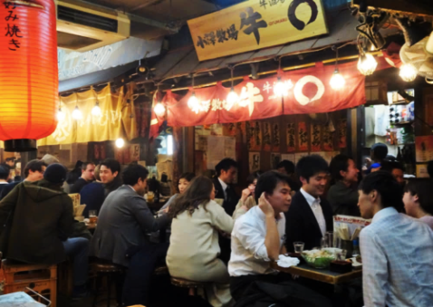
Optional Evening Tour (1) : Shimbashi Nightlife Tour

With its nostalgic atmosphere and old town vibe, Shimbashi is one of the most frequented business and entertainment districts of Tokyo. This area is famous for after-work social gatherings, and is usually filled with ‘salarymen’ and ‘office ladies’ who are known to be the typical Japanese office workers in black suits, who can usually be seen clutching black briefcases or shoulder bags.

Head down to one of the atmospheric local eateries and small Japanese-style pubs, which can be found below the train tracks along the Yamanote Line between Shimbashi and Yurakucho stations, for some drinks and appetisers. Start-off by raising a toast in the charming company of epicurean guides in a kushiage bar. Kushiage is a popular accompaniment to drinks, and consist of deep-fried skewered vegetables, seafood, and meat.

The next stop on the itinerary is a distinctive, cozy restaurant run by a charismatic owner who is well-loved by regular customers for her excellent cuisine and delightful conversation. A variety of seasonal dishes are on offer here. The third stop of the evening will be chosen based on the clients’ tipple of choice: Japanese craft beer, sake, or whisky.

Finally, visit Shimbashi Yokocho, a typical Japanese alley chock-full of those beloved Japanese eateries known as izakaya.

Be sure to bring an empty stomach and an adventurous spirit to make the most of this exclusive experience, which will offer insights into the customs and conventions of Tokyo’s nightlife.

Time:
Start: 17:00
Duration: approx. 3 h

Optional Evening Tour (2): Japan Whisky Adventure
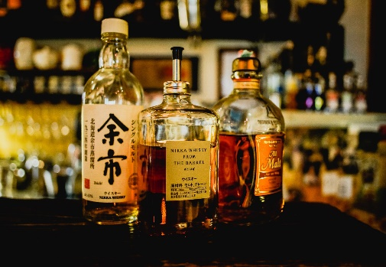
Scotland may well be the traditional home of the wee dram, but Japan has successfully made its mark on the world of whisky distillation. The Japanese culture of taking great pride in the art of patience as well as skill and craftsmanship has ensured success, and Japanese whisky has shot to fame and become prized across the world for its quality and innovation.

Join a whisky expert and experience a range of whiskies from hidden gems produced by microdistilleries to more recognised brands. Starting in a high-rise bar in downtown Tokyo, and then moving on to the next distinguished establishment, experiencing microdistillery whisky tasting, and followed by a final tipple in a classy basement bar – aficionados and novices alike are sure to enjoy a wonderful evening and a true journey of discovery of the senses.

Time:
Start: 16:45
Duration: approx. 4 h

Day 4: Tokyo – Kaga Onsen (Kanazawa) | B/-/D

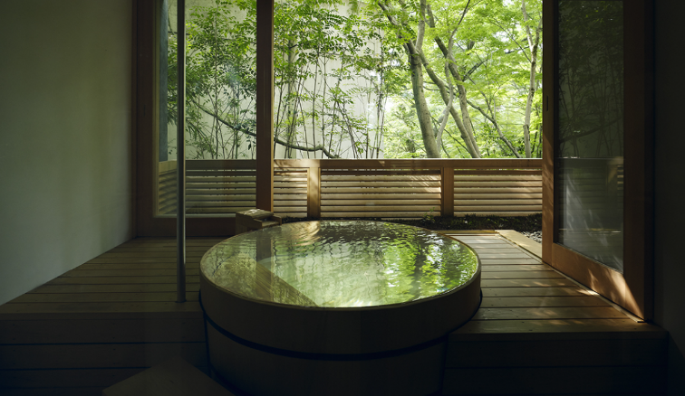
Today is a self-guided day.

Leave the hustle and bustle of Tokyo behind and travel to Kaga Onsen near Kanazawa, a small yet elegant hot spring resort situated at the foot of the sacred Mt. Hakusan. Kaga Onsen welcomes guests who are in search for a relaxing escape. Its four onsen (hot spring), namely, Yamashiro, Yamanaka, Awazu, and Katayamazu, have unique characteristics, giving guests a variety of experiences. Public baths can also be found in the center of each town.

The rest of the afternoon is free at leisure to enjoy the ryokan and private onsen.

Dinner tonight will be kaiseki, or a multi-course Japanese meal, served within the dining area of the private living quarters.

Distances and journey time (approximation, by bullet train):
Tokyo to Kanazawa: 140 min
Kanazawa to Kaga Onsen: 60 min (private car)

Overnight in Kaga Onsen (Kanazawa) at Beniya Mukayu 5 Stars (Deluxe)

Day 5: Day Trip to Kanazawa, Castle and Geisha | B/-/D

This morning meet the driver in the lobby and transfer to Kanazawa by private car where the guide will be waiting. Start with the pristine Kenroku-en Garden, which is ranked as one of Japan’s top three gardens. The garden is home to the oldest water fountain in the country, a couple of teahouses, and a large villa that used to be the retirement home of one of the richest clans in Kanazawa. Adjacent to the garden is Kanazawa Castle, easily accessed through the Ishikawa-mon Gate.

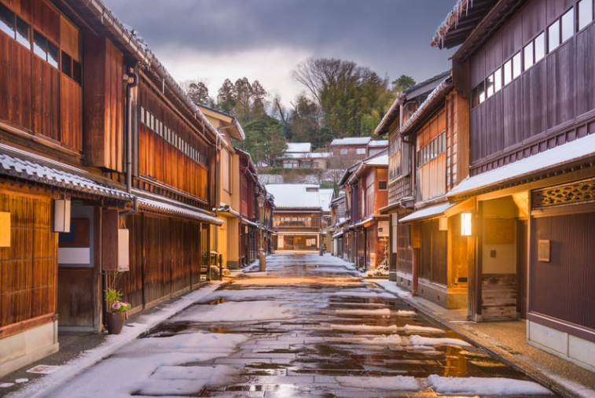
Lunch will be inside Omicho Market, known throughout Japan for its fresh seafood and fine sushi. The guide will introduce a local restaurant where some fine local cuisine can be sampled.

After enjoying a delectable lunch, head to the Higashi Chaya District, one of the three, well-preserved cha-ya districts in Kanazawa. Cha-ya, which means ‘tea house’ in Japanese, were where geisha used to entertain their guests with music, songs and dances. Here, find Hakuza, the shop that sells Kanazawa’s speciality – gold leaf products. The tearoom inside the shop is totally covered with gold! Be sure to indulge in one of Kanazawa's finest products - some gold leaf covered ice cream!

Delve into the world of Geisha culture during this insightful night out in Kanazawa. Reach the restaurant inside the famous Kenrokuen Garden, where dine admiring a geisha performing accompanied by the live performance of the Jiikata.
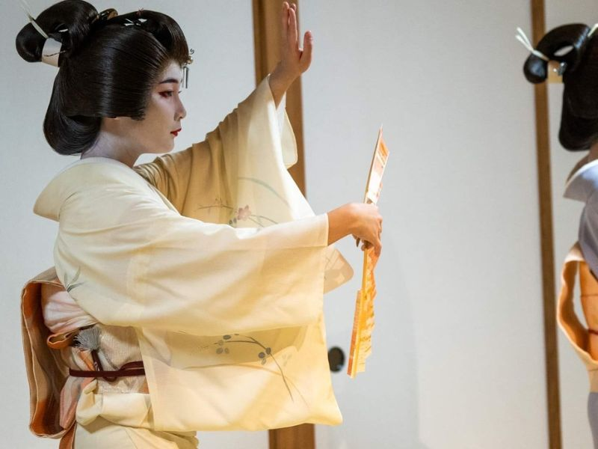
Get an in-depth, exclusive look at Japan’s geisha culture in Kanazawa. Late this afternoon join a guide for a walking tour of Kazue-Machi and Higashi-Chaya, two of the three Kanazawa’s ancient Geisha districts, before reaching the Kenrokutei, an exclusive Japanese restaurant inside the stunning Kenrokuen Garden.
Learn about Kanazawa geisha culture while exploring the traditional streets before seats in the exclusive location where the Geisha performance will take place.
Dine on a traditional multi-course meal called kaiseki ryori. During dinner, the two geisha will entertain by performing traditional dances and song. One geisha perform at the front, while the other one play the Shamisen at the back, following the classic style of ozashiki, the geisha performance.
After the dinner, enjoy the time chatting with the geisha and learn popular Japanese drinking games. Pose for photos with the geisha, capturing memories to share with friends and family back home, before bidding farewell to the hostess and returning to the hotel.
*Note that in spring season and when Kenrokutei Restaurant is not available, the dinner will be in a long-established restaurant in a traditional house.

Time:
Duration (guided tour): 6 h tour + 4hr dinner
*including pick-up, drop-off, and transit times

Overnight in Kaga Onsen (Kanazawa) at Beniya Mukayu 5 Stars (Deluxe)

Day 6: Kanazawa – Kyoto, Tea Ceremony and Kimono | B/-/-

Before taking the two-hour journey to Kyoto via Shinkansen (bullet train), enjoy one final soak in the onsen.
After check out, take the ryokan shuttle to Kaga Onsen Station and travel to Kyoto in Green Class. An assistant will be waiting in Tsuruga Station to assist with the change of trains to Kyoto.

Kyoto is home to an astonishing 2,000 shrines and temples, including 17 UNESCO World Heritage Sites.
Upon arriving in Kyoto, a private chauffeur will provide transport to the hotel for check in.

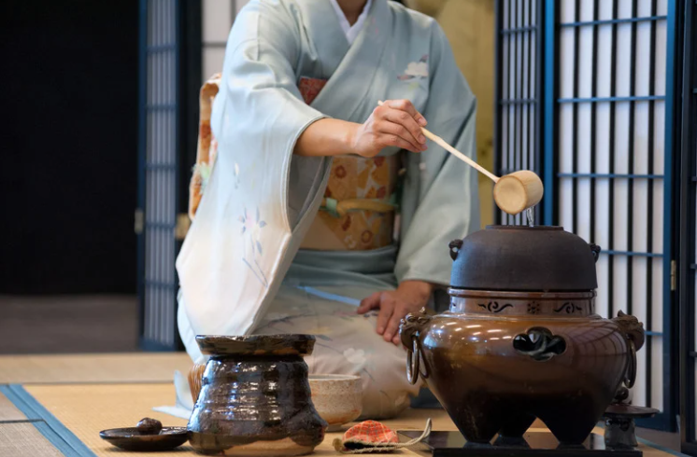
This afternoon, join a local master for a quintessentially Japanese experience: a tea ceremony in Kyoto. Inside the tea master’s private residence, be clothed in an exquisite kimono and get an in-depth introduction into the customs and history of this ritualistic ceremony. Learn about the correlation between tea ceremonies and Zen Buddhism while preparing and pouring tea the traditional way.
Take a closer look at one of Japan’s quintessential arts: the tea ceremony. Meet with a tea master in a private abode for an interactive cultural experience. Hear how the master studied for years to perfect the art of sado, or tea ceremony.
Before preparing the tea, get an introduction to Japan’s traditional and iconic attire – the kimono. After being helped into the magnificent garment, learn about the history of the ceremony. Explore its roots and find out how the rituals practised in the ceremony are closely related to the beliefs of Zen Buddhism. Then it is time to prepare the tea. Follow the master through the motions step-by-step, learning the reasons for each and every movement.
Once the tea is ready, the serving process begins. As with the preparation, the serving of the tea is also steeped in meaningful rituals. Before sipping the tea, delicate and delightful traditional Japanese confectioneries known as wagashi are eaten, sweetening the tongue to make the matcha tea taste less bitter, and creating a mouthful of harmony in the process.
After sipping the healthy brew, return the kimono and bid farewell to the tea master, taking away lasting memories of this incredible glimpse into Japanese culture and tradition. The experience will end with a private transfer back to the hotel.
Distances and journey time (approximation):
Kanazawa Station to Kyoto Station: 2 h

Time:
Duration: 3 h

Overnight in Kyoto at Six Senses Kyoto 6 Stars (Super Deluxe)

Day 7: Kyoto, Market and Temples | B/L/-
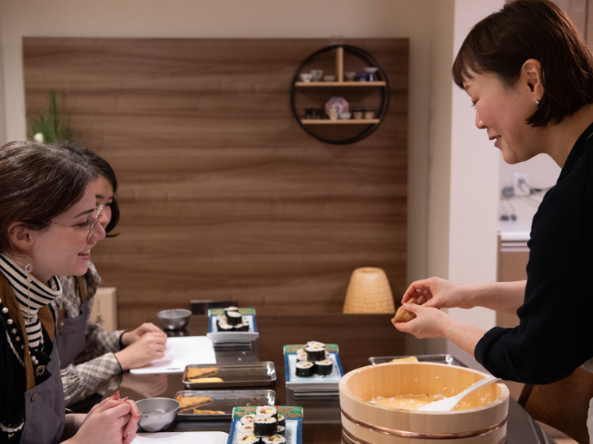
The center of downtown Kyoto is a bustling place; lively businesses selling goods, hurried locals coming and going from traditional homes, and shoppers searching for fresh ingredients in the market. Discover this charming neighborhood like a local with a visit to the famed Nishiki Market alongside a private guide followed by a private lesson on making a homestyle sushi meal.
With the guide, enter Nishiki Market, Kyoto’s legendary mile-long covered shopping street. For centuries, this has been considered “Kyoto’s kitchen” where the city’s best cooks can find the freshest ingredients.

After shopping for today’s ingredients, stop at a small lantern shop not normally open to tourists. For nine generations, traditional bamboo and paper lanterns have been crafted here. Say hello to the craftsmen and see their wares up close.

After a short walk, arrive at a renovated machiya, a traditional Japanese townhouse. Elegant and modern in style, this is the venue for today’s cooking lesson.

Begin with a casual sake tasting, trying a few different types and selecting the one that best suits the guest.

Enter the kitchen and learn how to prepare three kinds of rolled sushi. From traditional maki handrolls to cute temari sushi balls, a delicate touch and a lot of fun go into creating these delicious rolls. Miso soup, a side dish, and dessert will also be prepared by guests.

Finish by enjoying the delicious handmade meal.

Part ways with the instructor and meet the guide for an afternoon tour.

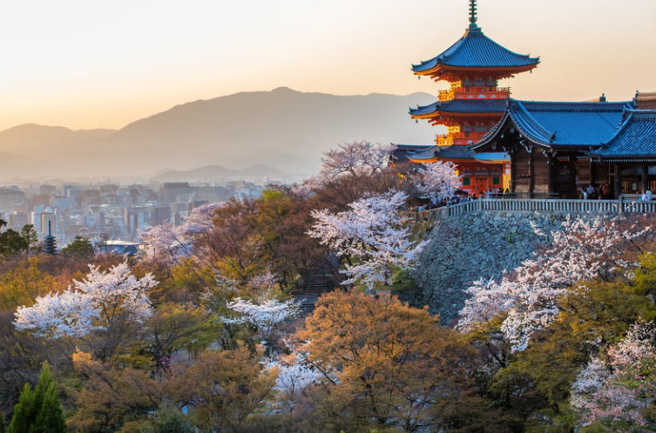
Start with Sanjusangendo, a stunning Buddhist site often overlooked by tourists. A mesmerizing display of 1001 life-sized golden Buddhist statues awaits inside the world’s longest wooden building, sure to be one of the most memorable sights of the entire trip.

Hop in a taxi for a short ride to the slope leading to Kiyomizudera Temple. Lined with traditional shops, the walk to the temple is a classic Kyoto street that leads to the most iconic site in eastern Kyoto. See the finely painted pagoda and wooden stage of Kiyomizudera, constructed only with wooden joinery and offering sweeping views of the city below.

Walk through more traditional streets to arrive at the quiet Kenninji Zen Temple. Renowned for its artwork, this temple displays ink paintings of serene landscapes and a massive dragon mural on the ceiling of the main hall. A classic Zen rock garden completes the experience, offering a chance to pause and reflect on the meaning of the minimalist dry landscape.

Time permitting, finish with a short walk through Gion, the historic geisha district.

Time:
Duration (guided tour): 8 h
*including pick-up, drop-off, and transit times

Overnight in Kyoto at Six Senses Kyoto 6 Stars (Super Deluxe)

Day 8: Kyoto, Rickshaw and Bamboo Forest | B/-/-
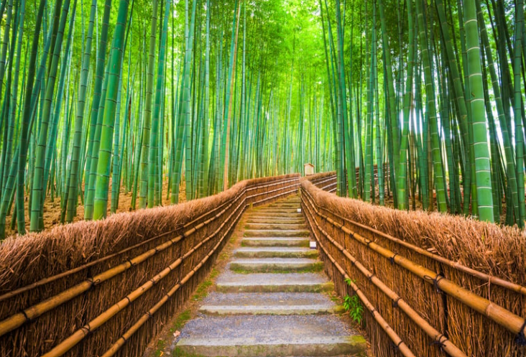
This morning, meet the guide at the hotel and travel to the Arashiyama District.

First get a different perspective of Kyoto with a memorable rickshaw ride through the heart of the Arashiyama district.

The Arashiyama rickshaw tour begins at Togetsukyo Bridge, one of Arashiyama’s most recognizable landmarks. Snap photos of the wooden bridge and the peaceful Katsura River. Then hop on a traditional Japanese rickshaw and enjoy an extensive tour of historic Arashiyama.

The expert driver will pull the rickshaw around the main highlights of the area as well as some hidden gems. The rickshaw is the perfect way to see Arashiyama, covering more ground than a walking tour but still slow enough to enjoy the sights and sounds of this charming town.

Weave in and out of local neighbourhoods, getting a closer look at the machiya, or traditional Japanese houses.

Upon reaching the end of the tour, return to Togetsukyo Bridge, bidding farewell to the rickshaw driver and returning to central Kyoto.

Meet the guide again after the ride and travel to Nonomiya Shrine which served as the setting of The Tale of Genji, a book commonly referred to as the world’s first novel. Here many come to pray for a happy marriage, seeking luck in finding a love one or for fertility. At the temple pick up heart shaped “ema”, a small wooden plaque used to make a wish. Perfect for writing down personalised prayers for a happy romance, than hang it with the others at the shrine. Other souvenirs are available such as good luck matching rings or Enmusubi amulets for a good relationship.

Stop for a tea break in the garden at the traditional home of Japan’s first silent film movie star at Okochi Sanso Garden, and then walk through the famous Arashiyama bamboo forest.

Say goodbye to the guide in Arashiyama and the rest of the day is free at leisure

Time:
Duration (guided tour): 5 h
*including pick-up, drop-off, and transit times

Overnight in Kyoto at Six Senses Kyoto 6 Stars (Super Deluxe)
Day 9: Departure | B/-/-

The rest of the day is at leisure until transport by private vehicle to Kansai International Airport for the departing flight.

Distance and journey time (approximation):
Osaka to Kansai Airport: 90 min

Extension Option 1 : Okinawa Beaches

Day 9: Kyoto – Miyakojima | B/-/-
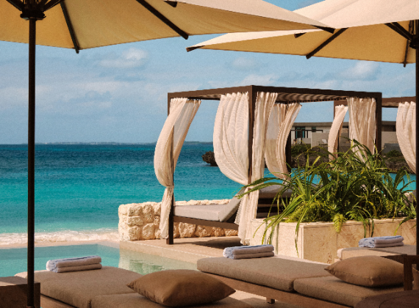
This morning, private transport will be provided to Kansai Airport for the flight to Okinawa, an island chain located halfway between Japan and Taiwan.

During its long history, Okinawa has been both an independent country, as well as a protectorate under Chinese and U.S. rule, giving it a colorful culture found nowhere else in Japan.

Welcome to Miyako Island, a tropical paradise 300 kilometres southwest of Naha, known for vivid blue water and stunning white sand beaches. It’s a relatively small island that can be crossed by car in only 45 minutes, home to beautiful scenery and exciting activities.

Distances and journey time (approximation):
Kyoto to Kansai International Airport (KIX): 2 h
Kansai Airport (KIX) to Miyakojima Airport (MMY): 2h 30 min (by plane)
Miyakojima Airport to Rosewood: 20 min

Overnight in Miyakojima at Rosewood 6 stars (Super Deluxe)

Day 10: Miyakojima | B/L/-
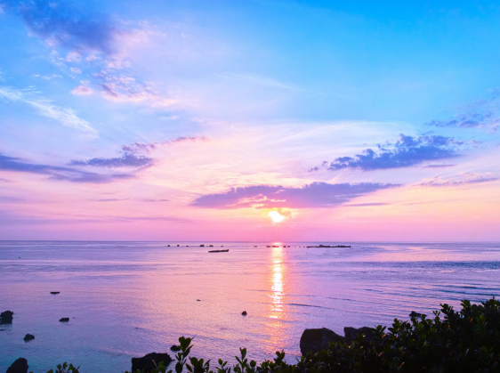
Formed by the uplifting of coral reefs, Miyako Island has long faced great challenges in securing fresh water.
As a result, local people developed ingenious ways to live, creating a lifestyle and culture rich with wisdom and resilience.
The island’s mangrove forests and subtropical jungles — treasure troves of biodiversity — have also evolved their own unique ecosystems.
Through this tour, explore the island’s historic sites and wander through its lush natural landscapes, gaining deeper insights into the life, nature, and culture that have shaped Miyako Island.
Time:
Duration (guided tour): 8 h
*including pick-up, drop-off, and transit times

Overnight in Miyakojima at Rosewood 6 stars (Super Deluxe)

Day 11: Miyakojima | B/-/-

Today is a self-guided day.

Today is at leisure in the resort. Either relax or enjoy one of the activities offered by the hotel (advanced booking required, extra fees may apply).

Overnight in Miyakojima at Rosewood 6 stars (Super Deluxe)

Day 12: Departure from Miyakojima | B/-/-

This morning, transfer to Miyako airport for the flight to Tokyo’s Airport.
Rosewood to Miyakojima Airport: 20 min

Extension Option 2 : Hokkaido Food and Wine

Day 9: Kyoto – Hokkaido (Shin Chitose) | B/-/D
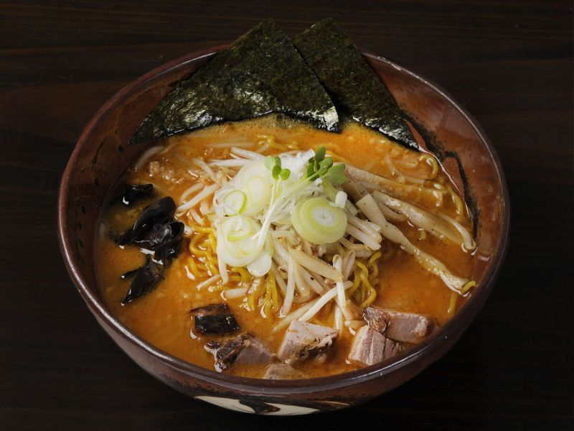
This morning, private transport will be provided to Kansai Airport for the flight to Hokkaido, Japan’s northern island.
Upon arrival to New Chitose Airport, our representative will be waiting to provide an escort to the hotel.

After head out to discover why Sapporo is a food-lover’s paradise on an evening food tour. Meet the guide at the hotel and depart for a three hour tour of Sapporo’s food scene.

The locations of tonight’s tour are tailored to the preference of the guest, with the guide providing recommendations for various type of local food. This includes iconic delights like Genghis Khan lamb barbeque or the city’s famous butter ramen. Seafood is on the menu as well for those who want to try regional specialties fresh from the coast.
Make stops in two of Sapporo’s most interesting neighbourhoods: the busy Tanukikoji shopping arcade, and the lively Susukino entertainment district.

Don’t forget dessert! Finish the tour with a Shime Parfait, a tantalizingly creamy ice cream dish made with Hokkaido cream.

After stops at two or three restaurants tailored to the guests’ tastes, bid farewell to the guide and continue exploring the city independently or head back to the hotel.

Time:
Start (guided tour): 18:00
Duration: 3 h
*including pick-up/drop-off and transit times

Distances and journey time (approximation):
Kyoto to Kansai International Airport (KIX): 2 h
Kansai Airport (KIX) to Shin Chitose Airport (CTS): 2h (by plane)
New Chitose Airport - Sapporo Station: 1 h

Overnight in Sapporo at Hotel Sosei 4 stars (Superior)

Day 10: Sapporo: Day Trip to Yoichi | B/L/-

Set out for a day exploring Yoichi, one hour away from Sapporo by car. The coastal climate and fertile soil have turned this seaside town into one of Japan’s most popular wine producing areas.

Arrive in Yoichi where a local guide awaits. Move by car to a local winery to begin exploring the liquid landscape of the region. Meet the owner of the establishment and taste local vintages together, discovering what makes Hokkaido wine so special.
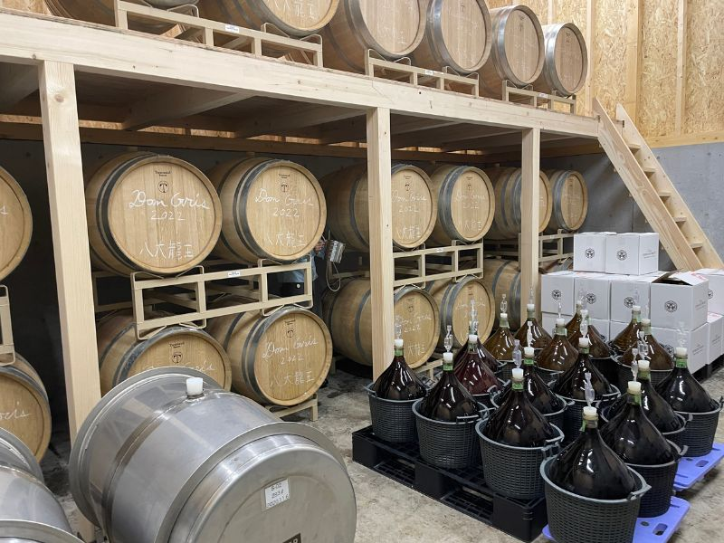
Return to town and drop by the local supermarket to explore Yoichi’s seafood to fully grasp the culinary scene here. The guide will then drop guests at a fashionable hotel restaurant built to showcase Yoichi wine and cuisine using local produce.
Among the hotel’s chic interior, savour a lavish lunch that pairs western-inspired courses of local meat and seafood with regional wine. The rarest Yoichi wine is highly sought-after, and today will be a chance to try some of these special vintages. This is a once-in-a-lifetime meal for wine lovers, carefully overseen by a highly regarded chef and sommelier duo who know the relationship between their cellar and the local dishes.

After a lunch say goodbye to the guide and visit the pride of Yoichi, the venerable Nikka Whisky Distillery, established in 1934 by Taketsuru Masataka, the father of Japanese Whisky (Selfguided). He found that the conditions in Yoichi are suprisingly close to those in Scotland where he learned his craft. We suggest skipping the guided tour (offered in Japanese only) and instead visiting the museum and shop on the premises, where guests can sample rare whisky for a small fee (not included).
Time:
Start (guided tour): 8:30
Duration: 7.5 h + transfer to/from Sapporo

Overnight in Sapporo at Hotel Sosei 4 stars (Superior)

Day 11: Sapporo at leisure (Optional Tours) | B/-/-

Today is a self-guided day.

Explore Sapporo or enjoy a pleasant day trip to Otaru.

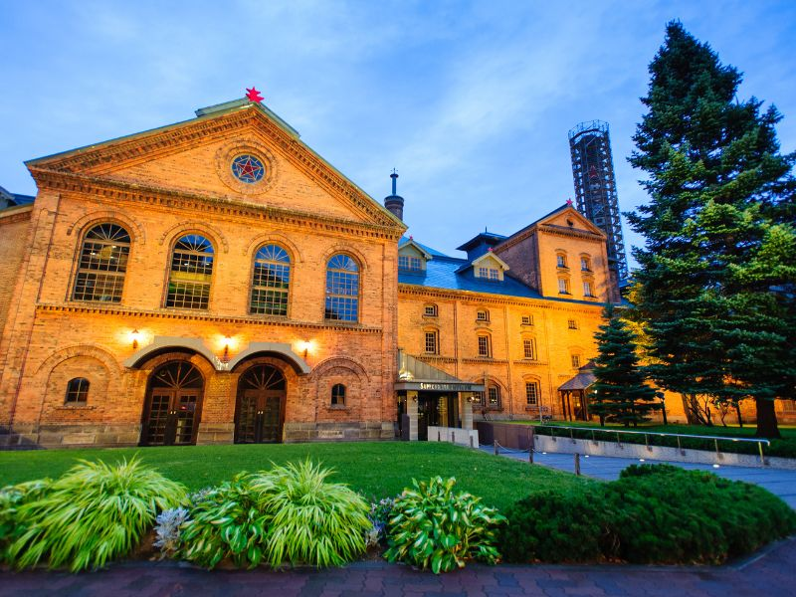
Optional Tour: Classic Sapporo City Tour
Explore a lesser-known side of Sapporo with a local guide. Visit the peaceful Maruyama neighborhood and Mt. Okura, a hidden gem offering stunning city views without the crowds. Learn about the city’s Olympic legacy, enjoy a seafood lunch at the central market, and taste fresh beer at the historic Sapporo Beer Museum. End the tour with helpful tips for exploring the city at leisure.
Meet a guide at the hotel in Sapporo, then walk together to the nearest subway station and ride to Maruyama, a serene and upscale neighborhood.
From there, take a taxi to Mt. Okura. Unlike Mt. Moiwa which is always very busy, Mt. Okura is a more hidden gem known mainly to locals, yet it offers equally stunning views of the city. In the right season, lucky visitors may catch a glimpse of ski jumpers in action from the top of the hill. Even if there is no practice or competition on there, it’s still possible to take the ski lift up to the top and experience just how thrilling - and intimidating - it must feel jumping toward the heart of Sapporo.

At the base of the hill is the Sapporo Olympic Museum. The 1972 Winter Olympics held here were the first to take place in Asia and played a key role in Sapporo’s development.

After visiting the museum, take a taxi to the Sapporo central wholesale market for a lunch of fresh seafood or other local dishes. Then, hop on a train to the Sapporo Beer Museum, to learn why brewing is so central to the city’s history and enjoy a glass of fresh beer.

Finally, return to central Sapporo by taxi. While walking through the center of Sapporo, the guide will give tips on how to explore the city independently, including suggestions for dinner spots and how to make the most of any free time.

Part ways with the guide and continue exploring Japan’s northern capital or return to the hotel. (L)

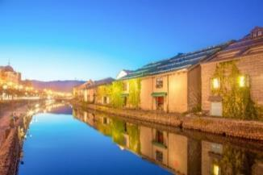
Suggested self-guided itinerary: Otaru

Otaru, located just a short train ride from Sapporo, is a charming port town that offers visitors a glimpse into Japan's rich cultural heritage. One of the main attractions is the Otaru Canal, a picturesque waterway lined with stone warehouses that were once used to store goods from ships. Today, the warehouses have been converted into restaurants, cafes, and shops selling local crafts and souvenirs.

Another popular spot is Sakaimachi Street, a historic shopping street that has retained its old-world charm. The street is lined with beautifully preserved buildings from the early 20th century, which now house boutiques, glassware shops, and cafes. Visitors can also visit the Otaru Music Box Museum, which showcases a collection of intricately designed music boxes from around the world.

Otaru also has several museums and art galleries that are worth visiting, such as the Otaru Museum, which showcases the town's history and cultural heritage. Another interesting museum is the Nikka Whisky Yoichi Distillery, 30 minutes from Otaru by train to visit the historical buildings and taste some of its famous whisky.

Finally, Otaru is known for its delicious seafood and sushi. Visitors can sample some of the freshest seafood at the Otaru Sankaku Market, which offers a wide variety of seafood and other local specialties.

Distance and journey time (approximation):
Sapporo Station to Otaru Station: 30 min (train)

Overnight in Sapporo at Hotel Sosei 4 stars (Superior)

Day 12: Departure from Sapporo | B/-/-

Today is a self-guided day.

Today is at leisure until the reserved express train transfer to Sapporo’s New Chitose Airport to catch a flight to the next destination.

Distance and journey time (approximation):
Sapporo Station - New Chitose Airport (CTS): 1 hour

*****END OF SERVICES*****

Rates & conditions

Main Itinerary: Accommodation
City | Hotel | Hotel Category | Room Type
Tokyo | Fairmont | 6 stars | Gold Bay View King Room
Kaga Onsen (Kanazawa) | Beniya Mukayu | 5 stars | Japanese-Style Room  (with private onsen bath)
Kyoto | Six Senses | 6 stars | Superior King Room

Pricing: in JPY per person for shared double
Rates are valid until 31 December 2027

PRICING FROM:
 | Price per person | 2
2026 | REGULAR SEASON | 1,758,000
2027 | REGULAR SEASON | 1,933,800

Extension Option 1: Accommodation in Okinawa
City | Hotel | Hotel Category | Room Type
Miyakojima | Rosewood | 6 Stars | Beach Front Villa King

Pricing: in JPY per person for shared double
Rates are valid until 31 December 2027

PRICING FROM:
 | Price per person | 2
2026 | REGULAR SEASON | 567,000
2027 | REGULAR SEASON | 623,700

Extension Option 2: Accommodation in Hokkaido
City | Hotel | Hotel Category | Room Type
Sapporo | Hotel Sosei – MGallery Collection | 5 stars | Superior King Room

Pricing: in JPY per person for shared double
Rates are valid until 31 December 2027

PRICING FROM:
 | Price per person | 2
2026 | REGULAR SEASON | 317,500
2027 | REGULAR SEASON | 349,300

Pricing Notes:
- Japan experiences dramatic pricing fluctuations based on Festivals, Domestic holidays and in some instances on weekends. Please consult with your Travel Consultant for exact pricing over a specific date. Reservations during weekends, peak season, and Japanese public holidays will be subject to supplementary charges.

Notes:
- For safety reasons, some forms of transportation may stop operating in case of unfavorable weather conditions (i.e. helicopters, boats).
- Please inform your Travel Consultant of any special dietary requirements and/or physical conditions that you may have.

Note for the Geisha Dinner (Kanazawa):
- Please note that this experience has a strict cancellation policy of 20% cancellation fee if cancelled from one month after the booking date.

Our services include (main itinerary):
- Hotel accommodation with daily breakfast
- Meals as mentioned in the itinerary (B = Breakfast, L = Lunch, D = Dinner)
- Meet and greet at the airport (Day 1) and return transfers to the airport by private car
- 2-Day Hakone Free Pass
- Taxi transfer from ryokan to Odawara Station on Day 6
- Bullet train ticket from Odawara Station to Kyoto Station (reserved seats, green class)
- Private transfer from hotel in Kyoto to Kansai Airport on Day 9
- Roundtrip taxi transfers from Ishigaki Airport to hotel
- English-speaking guides for tours on Days 2,5,7-8
- All entrance fees and private transfers during guided days
- Wedding Kimono Experience and Photoshoot on day 3
- Dinner with a Geisha on Day 5
- Arashiyama Rickshaw tour on day 8

Our services include (Okinawa):
- Hotel accommodation with daily breakfast
- Meals as mentioned in the itinerary (B = Breakfast, L = Lunch, D = Dinner)
- Return transfers to the airport by private car
- Full Day Guided tour on Day 2 with light lunch

Our services include (Hokkaido):
- Hotel accommodation with daily breakfast
- Meals as mentioned in the itinerary (B = Breakfast, L = Lunch, D = Dinner)
- Return transfers to the airport by private car
- Food Tour on Day 1
- Guided tour on Day 2 with private car and lunch included

Our services do not include:
- International and domestic flights
- Some local transport (e.g. some local city buses, taxi transfers, etc.).
- Meals other than mentioned above.
- Personal expenses (e.g. drinks, laundry, telephone, and other expenditures of a personal nature).
- Travel insurance (please see below).
- Other services not clearly indicated in the package inclusions above.

LUGGAGE FORWARDING:
Baggage handling is not included in the above rates, but Japan has a fabulous luggage forwarding service which you can use to send your luggage to your next destination. It will take between 24 and 72 hours to get the luggage to the next point so we recommend preparing an overnight bag when using this service. Luggage can be sent between any two points in Japan and the bell desks or receptions at your hotel will be happy to assist you with arranging this luggage transfer.

IMPORTANT NOTES:
- We strongly recommend the purchase of travel insurance (covering emergency medical evacuation).
- Rooms at hotels are available only from 15:00 on arrival day till 10:00 on departure date. A supplement will be added if early check-in or late check-out is desired.
- Please note that all of the above services and tours have yet to be booked. They are proposed for your information only and we will not make any reservations before we receive your confirmation to do so.
- If one or some proposed service(s) is (are) not available at the time of booking, we will try to find other possibilities/options or other similar service(s) in order to avoid changes to the program.

