

HONEYMOON BREAK
JCTHMB
8 Days/7 Nights

Features:
- Explore Kyoto’s UNESCO sites
- Stay in an atmospheric inn
- Join a traditional tea ceremony
- Dine in the company of a Geisha
- Catch a glimpse of Mt. Fuji

Overview:
Be swept away by Japan’s culture and heritage on a romantic honeymoon escape. Enjoy exclusive activities designed for two while exploring Tokyo, Kyoto and Hakone. Share in uniquely Japanese experiences – from partaking in a tea ceremony to soaking in traditional onsens- to form memories that will last a lifetime.
Trip Outline

Day 1 | Tokyo, arrival | Day 5 | Hakone – Kyoto
Day 2 | Tokyo | Day 6 | Kyoto
Day 3 | Tokyo | Day 7 | Kyoto
Day 4 | Tokyo – Hakone | Day 8 | Kyoto, departure

Day 1: Arrival in Tokyo | -/-/-

Upon arrival to Tokyo airport, one of our representatives will be waiting to assist with transport into the city. After reaching the hotel, check in and enjoy the remainder of the day free at leisure.

The rest of the day is at leisure.

Optional Dinner:

For guests staying at the Park Hotel, enjoy the traditional Japanese Kaiseki cuisine at restaurant Hanasanshou. Alternative, the Tateru Yoshino offer a casual French food experience.

For guests staying at the Conrad Hotel, there are different restaurant options available, from French inspired cuisine to Asian specialties. We suggest the Japanese restaurant Kazahana, which offers refined Japanese cuisine for an intimate dining experience.
Note: Subject to availability and supplementary charges.
Overnight in Tokyo

Distances and journey time:
Narita International Airport (NRT) to Central Tokyo: 1.5 h
Haneda International Airport (HND) to Central Tokyo: 50 min

Day 2: Tokyo | B/L/-

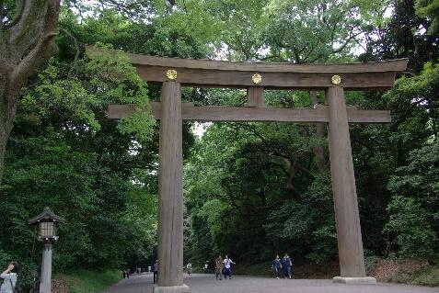
Meet up with the guide this morning in the hotel for the trip to Meiji Jingu, Tokyo’s most iconic Shinto shrine steeped in history and spirituality. Pass through the impressive torii gates leading to the shrine's inner forest of over 100,000 trees. Whether witnessing a traditional Shinto wedding procession or strolling through the lush grounds, Meiji Jingu provides an unforgettable experience of nature in the centre of Tokyo’s urban landscape.

Move on to the nearby districts of Harajuku and Omotesando, vibrant neighbourhoods that offer a unique and eclectic experience. Harajuku, renowned for its quirky street fashion, showcases an array of avant-garde boutiques and shops that cater to various subcultures. Omotesando, often dubbed Tokyo's "Champs-Élysées" presents a sharp contrast with its upscale, sophisticated atmosphere.

After lunch, use public transport to reach the beautiful Koishikawa Korakuen Garden, a traditional landscape that serves as an excellent example of Japanese garden design.

The final destination of the day is Asakusa. This charming district exudes a nostalgic charm and showcases
Tokyo's traditional side. At the heart of Asakusa stands the iconic Senso-ji, Japan's oldest Buddhist temple, drawing hordes of locals and tourists alike seeking blessings and cultural insight. The vibrant Nakamise Street leading to the temple offers a bustling market with a myriad of stalls selling traditional snacks, souvenirs, and handicrafts.

After a full day of touring the city, return to the hotel with the guide or part ways and continue exploring the city independently.

Time:
Start (guided tour): 09:00
Duration: 8 h
*including pick-up/drop-off and transit times

Note:
- The order of this itinerary may change depending on the location of your hotel.
Overnight in Tokyo

Day 3: Tokyo, Dinner with a Geisha Experience | B/-/D
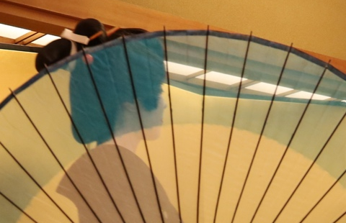
Today, continue the metropolis’ exploration independently until the evening.
Tonight’s experience takes place in Kagurazaka, one of Tokyo’s most traditional neighborhoods famous for its historical connection to the historic Edo period and geisha culture.

Meet a local guide in front of tonight’s venue and get ready to step inside the geisha world. Enjoy an authentic geisha performance showcasing traditional dance or live music. Engage with the geisha through traditional fun games. With the help the English-speaking guide, ask questions and learn all about their culture and personal stories, through this unique first-hand experience.

The meeting and performance with geisha will be accompanied by a traditional Japanese meal and all you can drink menu including Japanese sake, beer, and soft drinks based on preference.

Time:
TBA (anytime between 17:00 – 21:00)
Duration: approx. 2 h

Suggested Self-Guided Itinerary:

Enjoy the entire day exploring Tokyo or its outlying areas. Make an early morning stop to visit the electronics district of Akihabara or discover Tokyo’s world-class museums and art galleries. Alternatively, take an excursion outside of Tokyo to one of the following places:

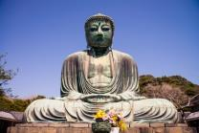
Kamakura
One of Japan’s former capitals, Kamakura is a delightful seaside town home to many ancient shrines, temples, and other structures like the Daibutsu, a giant bronze Buddha that stands at 13-meter tall.

Distance and journey time (approximation):
JR Tokyo Station to JR Kamakura Station: 50 min

Nikko
Located north of Tokyo, Nikko is a city that lies in the mountainous area of Tochigi Prefecture well-known for its national park. Some of the popular places in the park include the Toshogu Shrine complex and the Tamozawa Imperial Villa.

Distance and journey time (approximation):
JR Tokyo Station to JR Nikko Station: 2 h

Note: Roundtrip train tickets to Kamakura can be arranged at an additional cost.

Overnight in Tokyo

Day 4: Tokyo – Hakone | B/-/D

Today is a self-guided day.

Travel by train to Hakone, a popular hot spring destination from Tokyo frequented by most tourists who wish to get a sight of Mt. Fuji.
Optional Tour: Hakone Hiking Through History
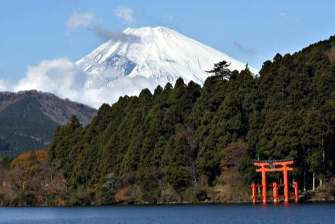
Meet a local guide and begin the walk along the Old Tokkaido Road, the historic highway whose cobblestone and dirt path still winds through Hakone. During the hike, the guide will tell stories of the travellers who once passed along the route and why this highway was a modern marvel of its time.

Pass through magnificent natural scenery, including lush forest, clam marshland, and dynamic rocky outcrops. Mt Fuji is also visible across Lake Ashi on clear days. The hike itself is not difficult, but expect approximately 6 hours of walking on a 6.5 km route with a 900 meter elevation change.

Make a stop at the reconstructed Hakone Checkpoint, a military gateway that guarded the approach to Edo. Pass through with the freedom that only high ranking samurai enjoyed, and explore the museum on site.

After a break for a casual lunch at a soba noodle restaurant, discover the local woodworking craft called “yosegi zaiku.” This delicate art is comprised of inlaid wooden pieces that are arranged into beautiful designs on various goods like decorative boxes and combs

Walk on to reach Amazake Chaya, a historic roadside teahouse that has been serving weary travellers for centuries. Enjoy some local amazake and sweets here before finishing up the hike.

Part ways with the guide and return to the hotel for rest and relaxation.

Time:
Start: TBD
Duration: approx. 7h

Suggested Alternative Itinerary:
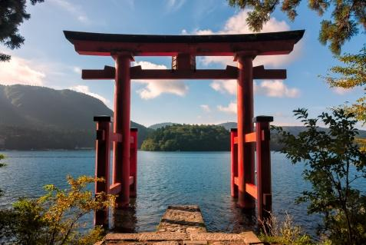
Head to Togendai and board the aforementioned replica of a pirate ship to cross Ashinoko, a lake that was formed after a volcanic eruption that took place more than 3,000 years ago.

Disembark at Hakone-machi and walk towards Hakone Shrine, one of the most photographed spots in Hakone for its iconic “floating” torii gate. The approach to the main shrine buildings is via a set of ninety-or-so stairs that go through the forested mountain.

In Hakone, experience a stay in a ryokan, a classic Japanese-style accommodation furnished with futon beds, tatami flooring, paper sliding doors, and hot spring baths.

Enjoy a traditional multi-course meal for dinner, which usually includes small servings of sushi, sashimi, and tempura.

Overnight in Hakone

Distances and journey time:
Tokyo Station to Hakone-Yumoto Station: 1 h

Day 5: Hakone – Kyoto | B/-/-

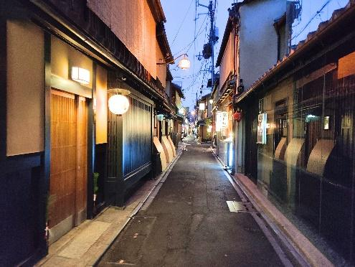
Take one last soak in the onsen before getting on the bullet train to Kyoto, the reigning cultural capital of Japan, home to 2,000 shrines and temples with 17 UNESCO World Heritage Sites.

Meet the guide at 18:30 in front of the famed Minamiza Kabuki Theatre and head out into the night for stops at up to three restaurants that all include food and drinks.

Begin with a walk through Gion, the historic geisha district. When evening falls, the streets are lit by lanterns and the traditional wooden building take on a charming glow. There is always the chance to spot a few geisha as they dart through the alleys on their way to meet clients.

Arrive at the first restaurant, a quiet members-only homestyle-cooking establishment run solo by a delightful woman with a passion for good food. This is the kind of place that is normally closed to walk-in and tourists, but the guide will have a reservation prepared. The menu here is mainly obanzai cuisine, an ever-changing assortment of small dishes focusing on daily market-fresh fresh vegetables. Look forward to cooked-to-order delicacies like simmered fish, stewed vegetables with chicken, slow-cooked miso beef, and the owner’s signature dish of lightly fried dumplings inside a slice of eggplant instead of dough.

Next, walk over the Kamogawa River to the Pontocho District, another geisha neighbourhood. Things are a bit livelier here, and a stop at a Kyoto-style izakaya (Japanese gastropub) awaits. A young couple operates this restaurant, greeting customers while keeping busy in the open kitchen preparing their original recipes. The specialty here is duck, long considered a classic Kyoto dish, and the menu has plenty of other options as well focused on vegetable and meat dishes cooked with rich dashi fish broth.

All restaurants include options for both alcoholic non-alcoholic drinks.

For guests who are still hungry after the two delicious restaurants, a final stop for a shime can be arranged. Shime (pronounced “she-may”) refers to a carb-heavy final dish to top off a night of eating, so that the space in your stomach can be saved for the good stuff first. Tonight’s Kyoto-style shime is classic bowl of soba buckwheat noodles. A final short walk through the district is an option for guests who are full, perhaps with a stop for a casual dessert of traditional Kyoto sweets.

After eating your way through two Kyoto districts, part ways with the guide and continue exploring the city’s nightlife independently. (D)

Time:
Start: 18:30
Duration: approx. 3 h

Overnight in Kyoto

Distances and journey time:
Odawara Station to Kyoto Station: 2 h

Day 6: Kyoto | B/-/-

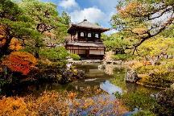
Escorted by a local guide, travel to eastern Kyoto and explore some of the hidden pathways that lead to historical places and UNESCO World Heritage sites.

Begin with a visit to Ginkaku-ji, a simple Buddhist temple situated at the foot of Higashiyama mountains. Its well-maintained, moss-covered gardens filled with luscious trees are what invite some of the more nature-loving tourists. The view of the Silver Pavilion and the green temple grounds surrounded by a sea of concrete buildings can be enjoyed from the observation point on the side of the mountain.

From the temple, embark on the historical walk on Philosopher’s Path, a narrow, cobblestone road along a tranquil canal lined with cherry (sakura) trees, seasonal flowers, and maple trees.

At the end of the trail is a grand temple known as Nanzen-ji famous for a number of things including the huge wooden Sanmon Gate and a historical brick aqueduct that dates back to the Meiji Period.

Head southeastward to Maruyama Park passing through Nene-no-Michi, a back street lined with traditional inns, small restaurants, and serene temples. This path links Yasaka Shrine and the approach to Sannen-zaka, one of the busier slopes that lead to Kiyomizu-dera Temple.

End today’s tour in Kiyomizu, a Buddhist temple situated near Mt. Otowa. The temple is famous for its wooden veranda standing 13 meters tall and was built without the use of any nails. It offers breathtaking views, especially when the cherry blossoms are in bloom or when the leaves change color in fall.

Time:
Start (guided tour): 09:00
Duration: 8 h
*including pick-up/drop-off and transit times

Overnight in Kyoto

Day 7: Kyoto | B/-/-

Today is a self-guided day.

Suggested Self-Guided Itinerary:
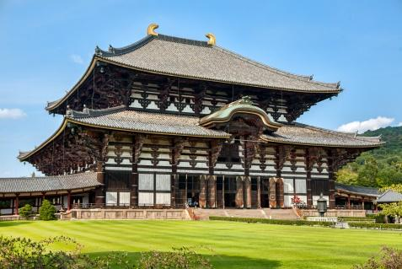
In the morning, head out of town and travel to Nara with the Japan Rail Pass. During the 8th century, Nara was Japan’s capital and many of the temples and shrines built at that time still remain.

Nara is just a small town, with most of its main tourist spots located around Nara Park, home to a large number of tame deer. Visit Todaiji Temple, the world’s largest wooden building home to Japan’s largest Buddha, or Kasuga Taisha, Nara’s most celebrated shrine.

Distance and journey time (approximation):
Kyoto Station to Nara Station: 45 min

Overnight in Kyoto

Day 8: Departure from Kyoto | B/-/-

The rest of the day is at leisure until the scheduled transfer via shared shuttle to Kansai International Airport.
Distances and journey time:
Central Kyoto to Kansai International Airport (KIX): 2 h

Rates & conditions

4-star accommodation
Accommodation
City | Hotel | Hotel Category | Room Type
Tokyo | Park Hotel Tokyo | 4 Stars | Queen Room Tokyo Tower View
Hakone | Kowakien Tenyu | 5 Stars | Japanese-Style Room  (with private onsen bath)
Kyoto | Noku Kyoto | 4 Stars | Deluxe Room

4-Star pricing: in JPY per person for shared twin/double
Rates are valid until 31st December 2027

PRICING FROM:
Validity Date |  | 2
2027 | Regular Season | 456,500
2027 | Regular Season | 502,100

5-star accommodation
Accommodation
City | Hotel | Hotel Category | Room Type
Tokyo | Mandarin Oriental Tokyo | 5 Stars | Standard Room Bay View
Hakone | Gora Kadan | 6 Stars | Japanese-Style Room  (with private onsen bath)
Kyoto | The Mitsui | 5 Stars | Deluxe Room

5-star pricing: in JPY per person for shared twin/double
Rates are valid until 31st December 2027

PRICING FROM:
Validity Date |  | 2
2027 | Regular Season | 863,300
2027 | Regular Season | 949,600

Supplement guide other languages
Language | Supplement per group (JPY)
German / French / Spanish/ Italian | 10,400 JPY per day  (For guides in Tokyo and Kyoto)
Note:
● Guides for other languages in more remote areas cannot be guaranteed.

Accommodation Note:
- We will propose an alternative should any of the abovementioned properties become unavailable.

Pricing Note:
- Japan experiences dramatic pricing fluctuations based on Festivals, Domestic holidays and in some instances on weekends. Please consult with your Travel Consultant for exact pricing over a specific date. Reservations during weekends, peak season, and Japanese public holidays will be subject to supplementary charges.

Notes:
- Nijo Castle is closed on Tuesdays (or if Tuesday is a National holiday, closed the following day).
- For safety reasons, Hakone Ropeway, and some other public transport, may stop operating in case of unfavorable weather conditions.
- Please inform your Travel Consultant of any special dietary requirements and/or physical conditions that you may have.

Our services include:
- Hotel accommodation with daily breakfast
- Meals as mentioned in the itinerary (B = Breakfast, L = Lunch, D = Dinner)
- English meet and greet at the airport and return transfers to the airport
- Tokyo Kagurazaka Dinner with a Geisha on Day 3
- One way train ticket on ordinary car on Days 4, 5
- 2-Day Hakone Free Pass from Day 4
- English-speaking guides for tours on Days 2, 6, and 7 (supplementary charges apply for other languages)
- All entrance fees and public transportation fees as mentioned in the itinerary on Days 2, 6, and 7
- Japanese cultural experience in Kyoto on Day 5
- Self-guide app and customised travel documentation

Our services do not include:
- International and domestic flights (quoted separately)
- Some local transport
- Meals other than mentioned above
- Personal expenses (e.g. drinks, laundry, telephone, and other expenditures of a personal nature
- Travel insurance (please see below)
- Other services not clearly indicated in the package inclusions above

LUGGAGE FORWARDING:
Baggage handling is not included in the above rates, but Japan has a fabulous luggage forwarding service which you can use to send your luggage to your next destination. It will take between 24 and 72 hours to get the luggage to the next point so we recommend preparing an overnight bag when using this service. Luggage can be sent between any two points in Japan and the bell desks or receptions at your hotel will be happy to assist you with arranging this luggage transfer.
IMPORTANT NOTES:
- We strongly recommend the purchase of travel insurance (covering emergency medical evacuation).
- Rooms at hotels are available only from 15:00 on arrival day till 10:00 on departure date. A supplement will be added if early check-in or late check-out is desired.
- Please note that all of the above services and tours have yet to be booked. They are proposed for your information only and we will not make any reservations before we receive your confirmation to do so.
- If one or some proposed service(s) is (are) not available at the time of booking, we will try to find otherpossibilities/options or other similar service(s) in order to avoid changes to the program

